2025 | NEW/RENEWAL MEMBERSHIP APPLICATION  INDIANA AMERICAN SADDLEBRED HORSE  ASSOCIATION, INC.  www.indianasaddlebred.net | 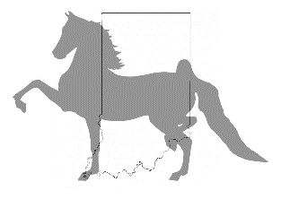

PLEASE CHECK

_____ SENIOR MEMBER (18 and over) $25.00/YEAR

_____ JUNIOR MEMBER (17 and under) $15.00/YEAR

_____ DONATE TO THE IASHA $____________

(Mr., Mrs., Ms.) _______________________________________________________

ADDRESS: __________________________________________________________

CITY: __________________________ STATE: ____ ZIP CODE: ______________

PHONE: __________________________________

EMAIL: ___________________________________

May we send your Newsletter via E-Mail? _____ Yes _____ No

Would you like to go paperless for all correspondence? ______ Yes ______ No

What barn are you associated with (if any)? _______________________________________

Are your horse(s) registered with ASHA under any other name than your first and last?
(Ex: trust, joint ownership, barn name, etc...) ______________________________________

PAYMENT ACCEPTED VIA CASH, CHECK, OR PAYPAL
Paypal Email: indianasaddlebred@gmail.com

INDIANA AMERICAN SADDLEBRED HORSE ASSOCIATION, INC.
3270 N New Jersey St
Indianapolis, IN 46205

******* High Points DO NOT start to accumulate until membership is paid *******
Membership valid from date of payment until December 31, 2025

