2026 | NEW/RENEWAL MEMBERSHIP APPLICATION  INDIANA AMERICAN SADDLEBRED HORSE  ASSOCIATION, INC.  www.indianasaddlebred.net  New for 2026:  - Each horse owned or leased by a member is only eligible for high points awards if the horse is "declared". Additional horses can be declared throughout the year using this declaration form. Each horse declaration will cost $10 (one horse is included with membership).  - All correspondence will be moving to email, we will no longer be offering paper mail.  - Payments submitted without forms or without forms filled out will be considered donations. | 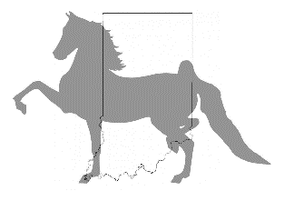

PLEASE CHECK

_______ SENIOR MEMBER (18 and over +1 horse declaration) $35.00/YEAR

_______ JUNIOR MEMBER (17 and under +1 horse declaration) $25.00/YEAR

_______ (#) ADDITIONAL HORSE DECLARATION $10.00/YEAR

RIDER NAME: ____________________________________________________________________________________

PARENT NAME (if applicable): ______________________________________________________________________

REGISTERED NAMES OF HORSES BEING DECLARED: _______________________________________________

_________________________________________________________________________________________________

______________________________________________________________________________________________________________________________________

ADDRESS: _______________________________________________________________________________________

CITY: _____________________________________________ STATE: __________ ZIP CODE: __________________

EMAIL: __________________________________________________________________________________________

What barn are you associated with (if any)? _______________________________________

PAYMENT ACCEPTED VIA CASH, CHECK, OR PAYPAL
Paypal Email: indianasaddlebred@gmail.com

INDIANA AMERICAN SADDLEBRED HORSE ASSOCIATION, INC.
3270 N New Jersey St
Indianapolis, IN 46205

******* High Points DO NOT start to accumulate until membership is paid *******
Membership valid from date of payment until December 31, 2026

